- Create 4 VPCs in 4 different regions and set up Transit Gateway.
- Do not use default VPCs.
- Prepare a document with all the screenshots and push it to a GitHub repo, then share the URL.
Created vpc from east-1 and its subnet and route
Here we have created 2 subnet pub and pri
In pub we gave internet access
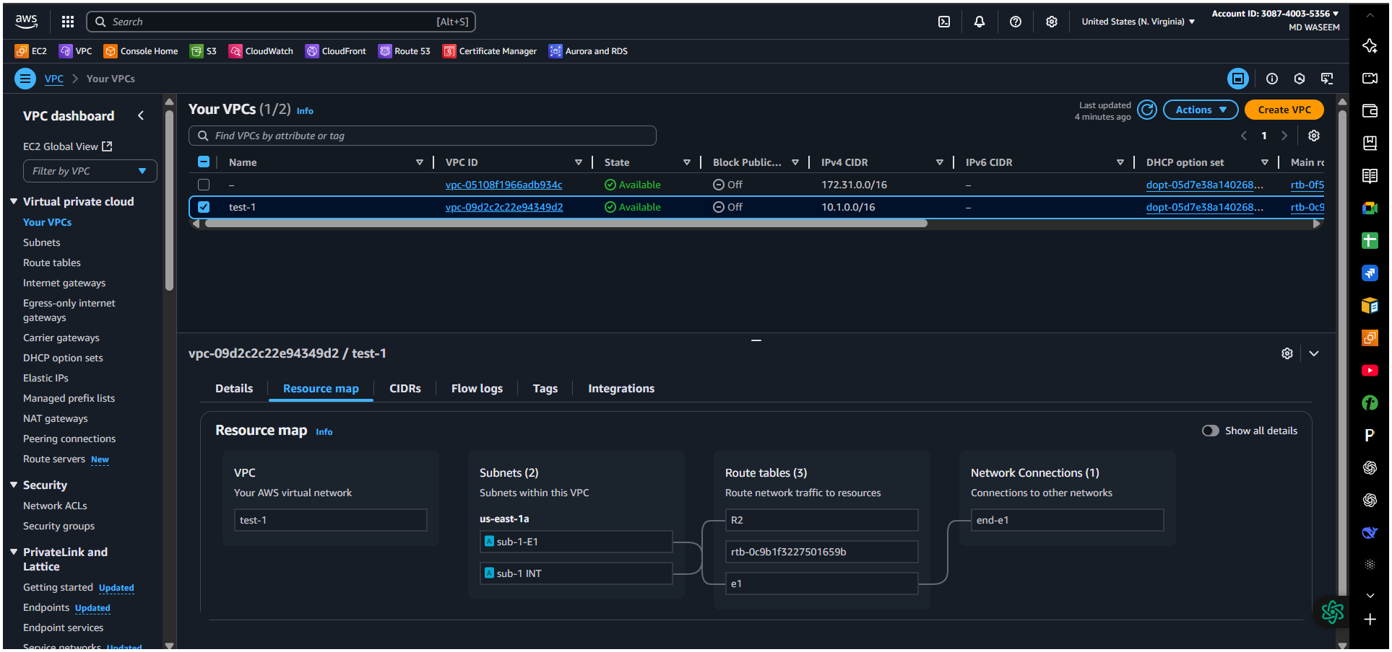
Created vpc east-2 and its subnet and route
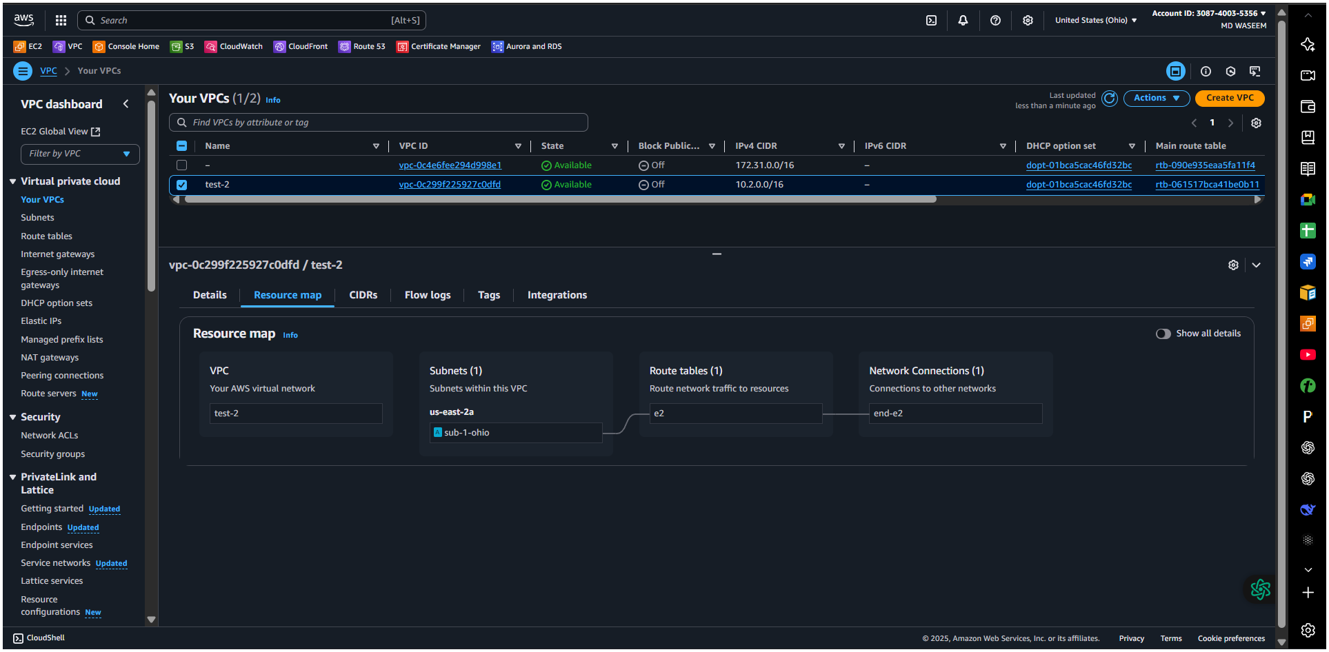

Created vpc west1 and its subnet and route
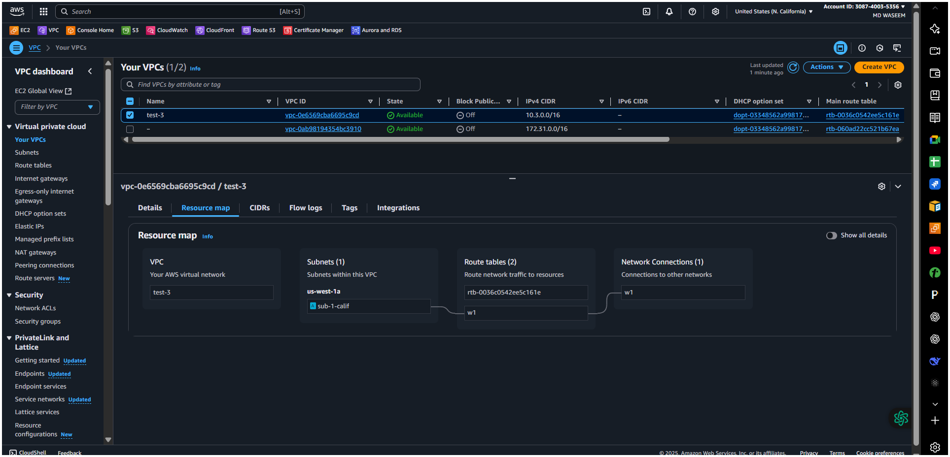
Created vpc west2 and its subnet and route
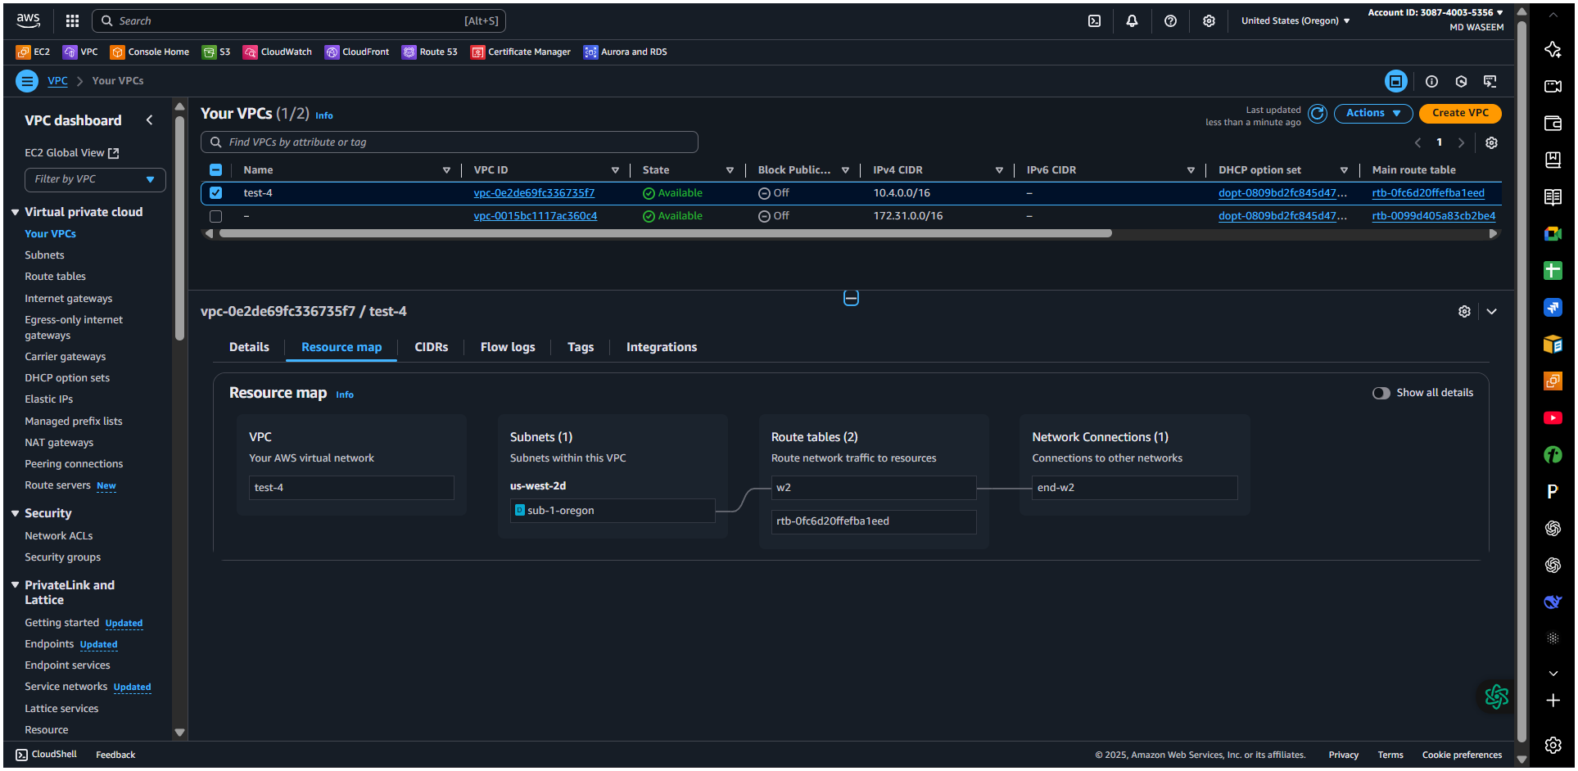

Then we have to created transit gateway for every 4 region (east-1)
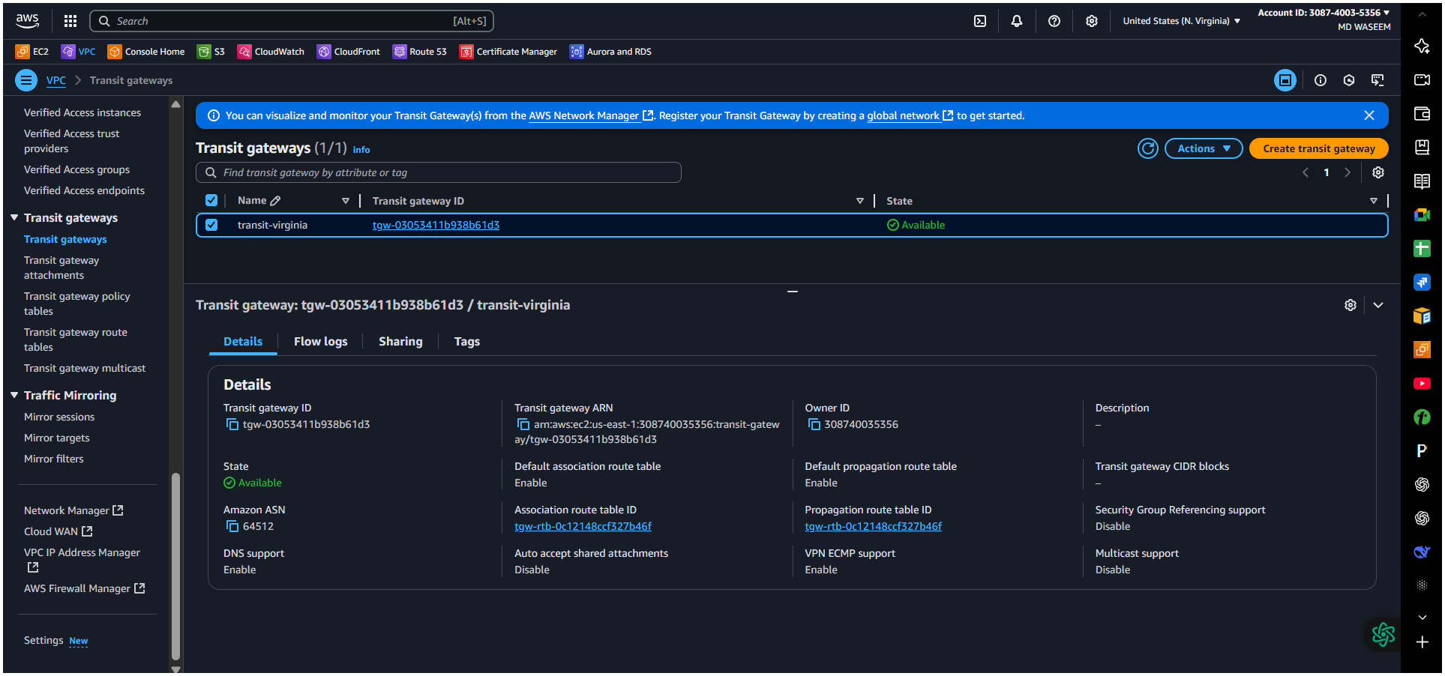
transit gateway region (east-1)
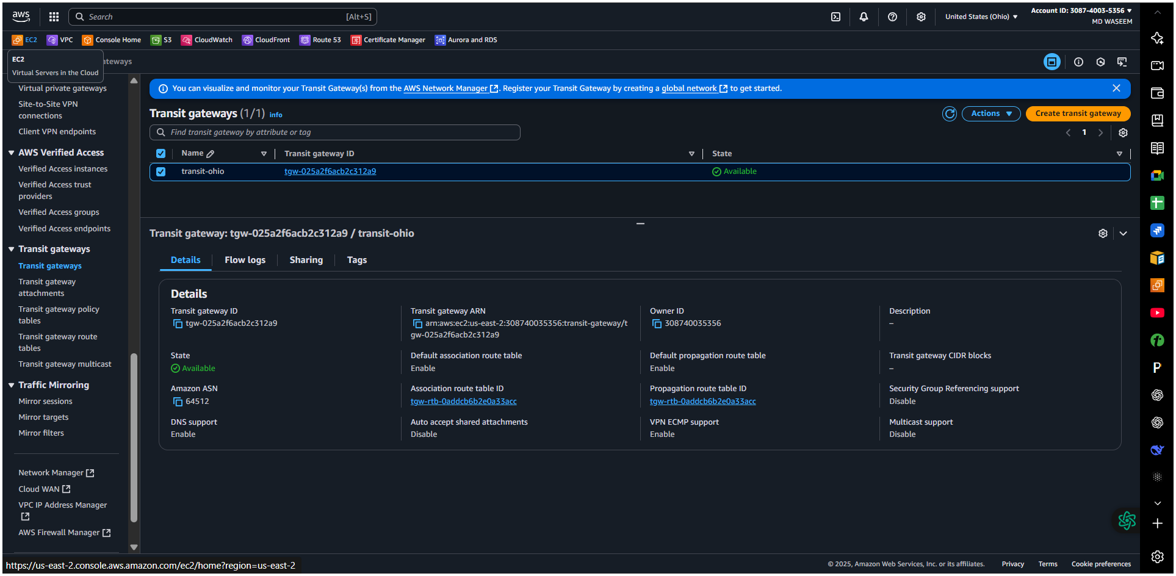
create transit gateway region (west-1)
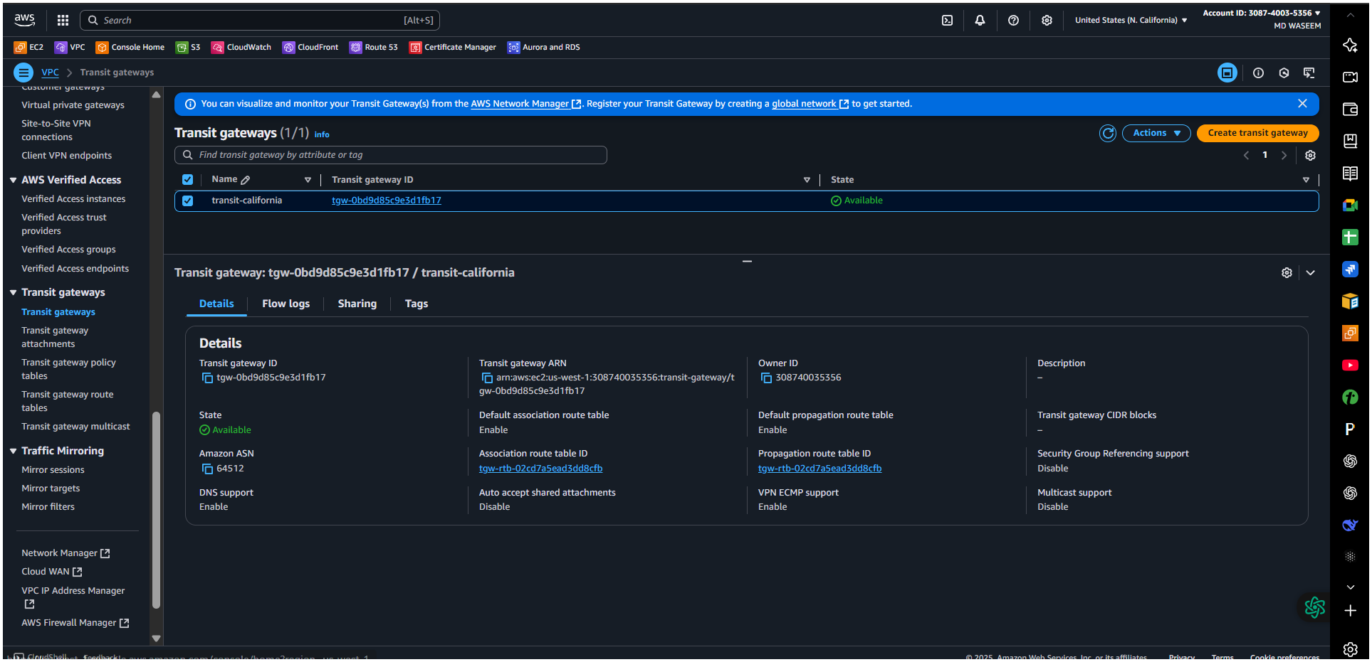
transit gateway region (west-2)
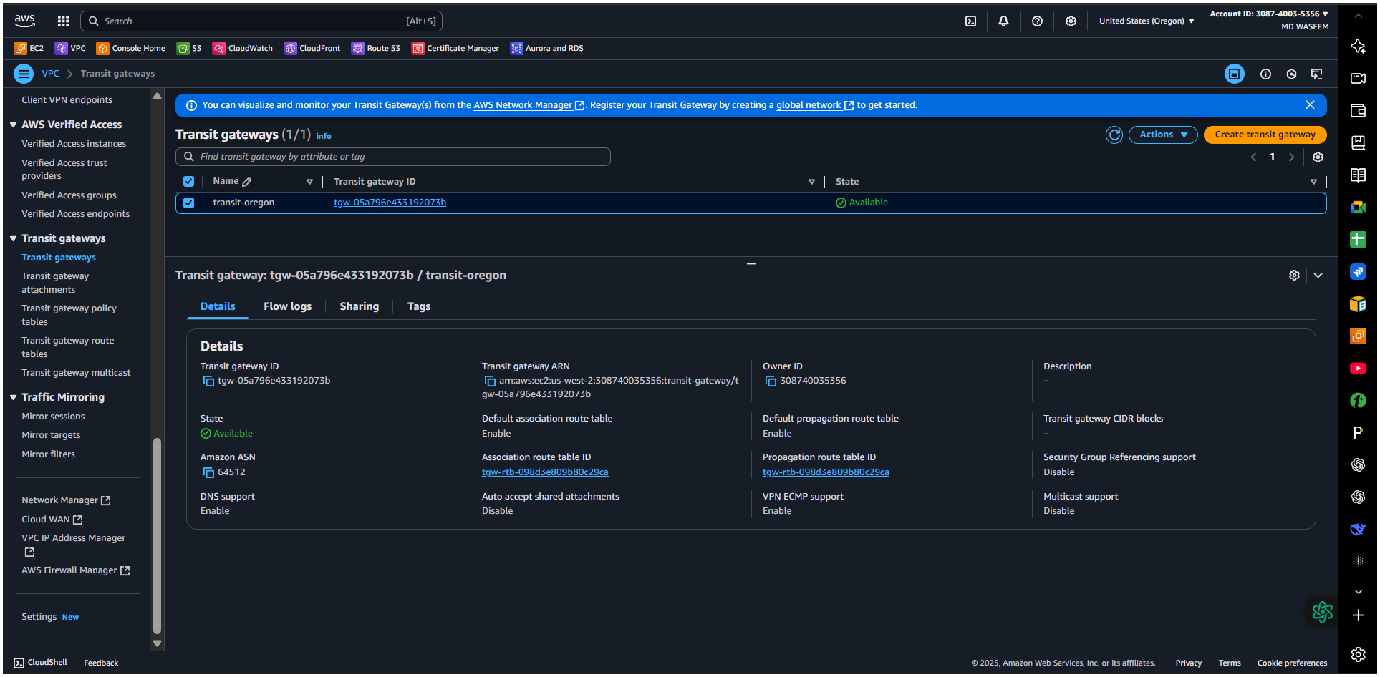

Now we have to create transit getway attachment and also need add peering of all other 3 region by attachment transit id with it…
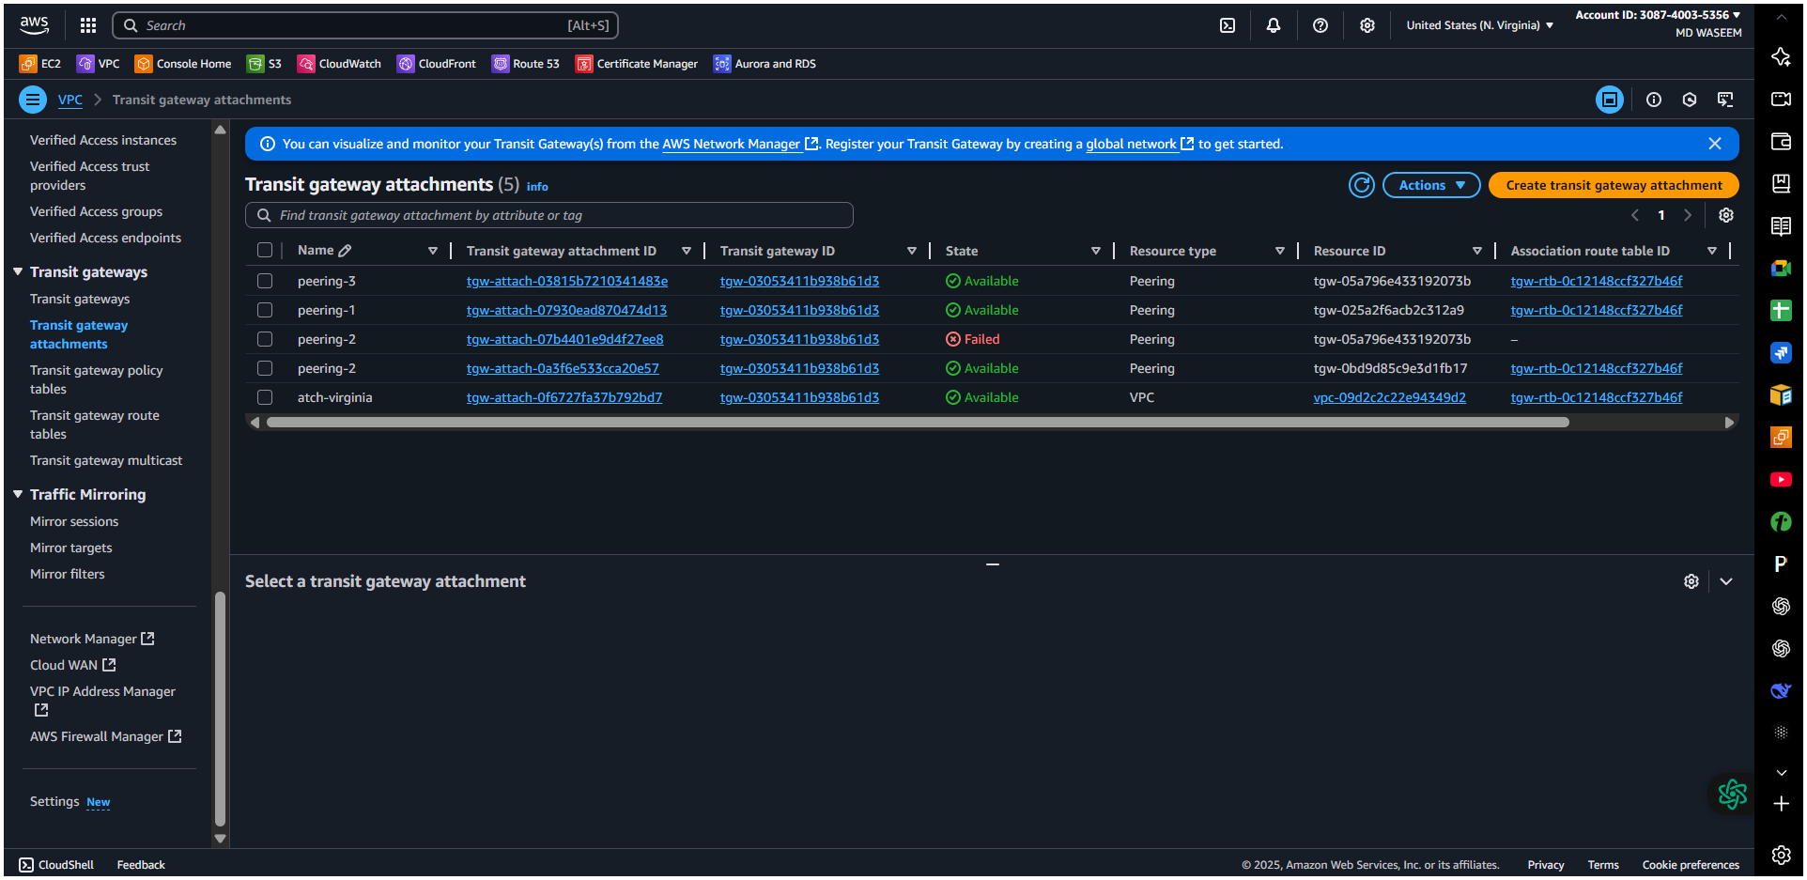
Accepted from ohio east 2
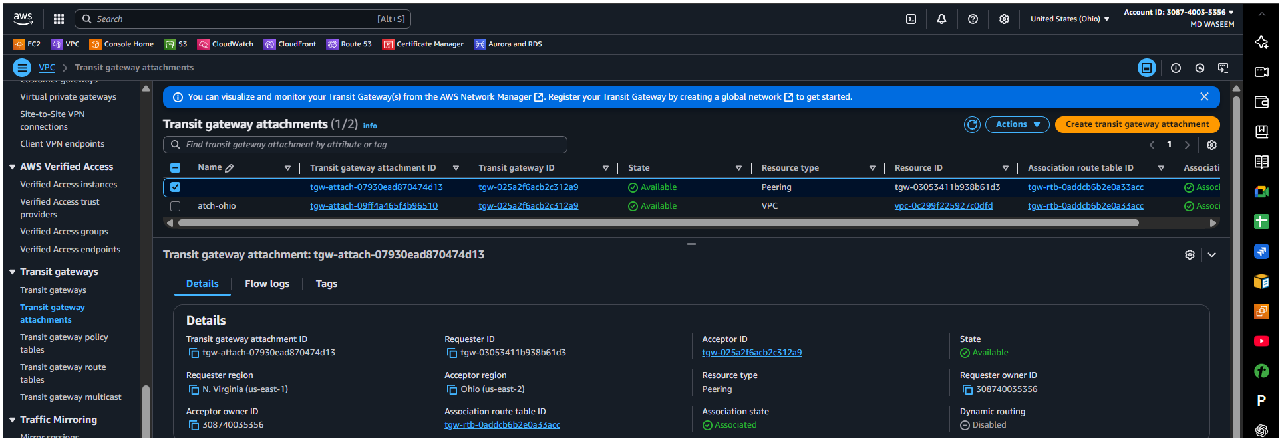

Accepted from west 1
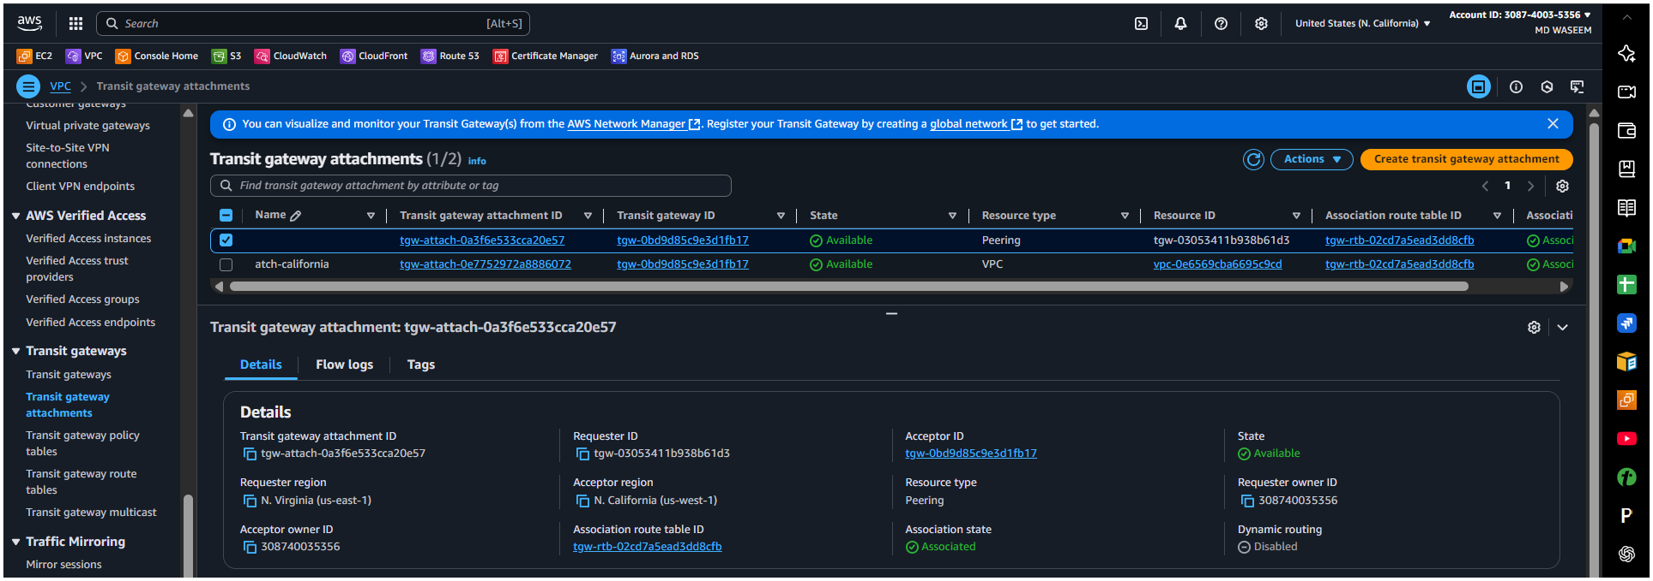

Accepted from west2
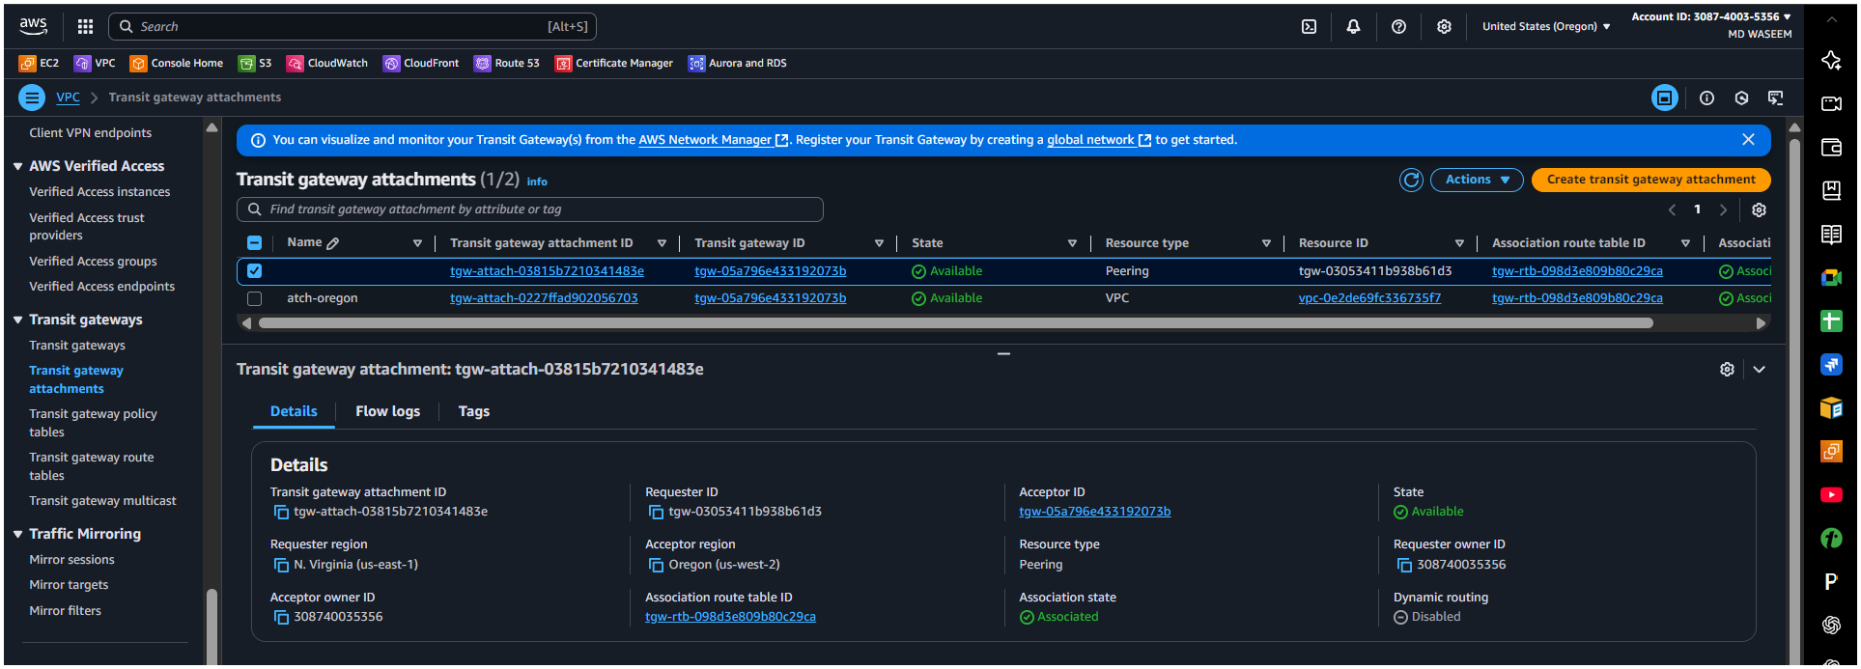
Endpoint form virginia east1
Here we need to interface and gateway for all 4 region
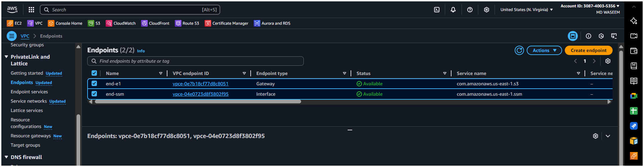
Endpoint form virginia east2
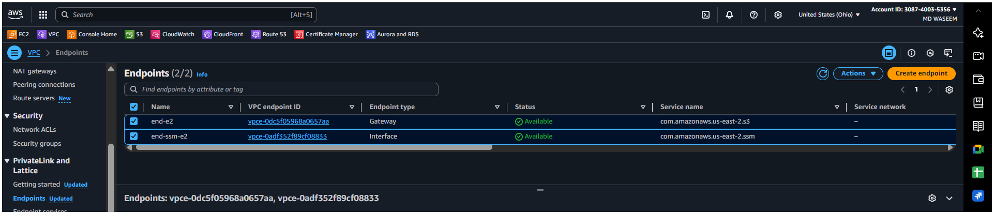
Endpoint form virginia west-1
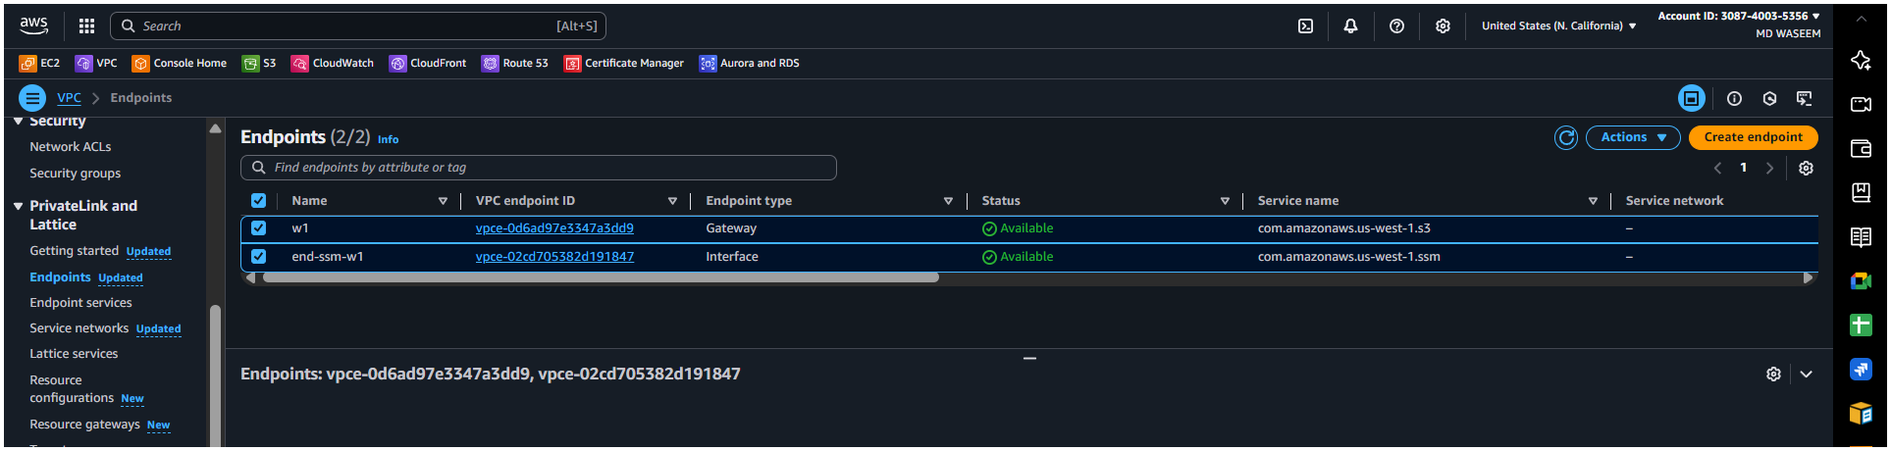

Endpoint form virginia west 2
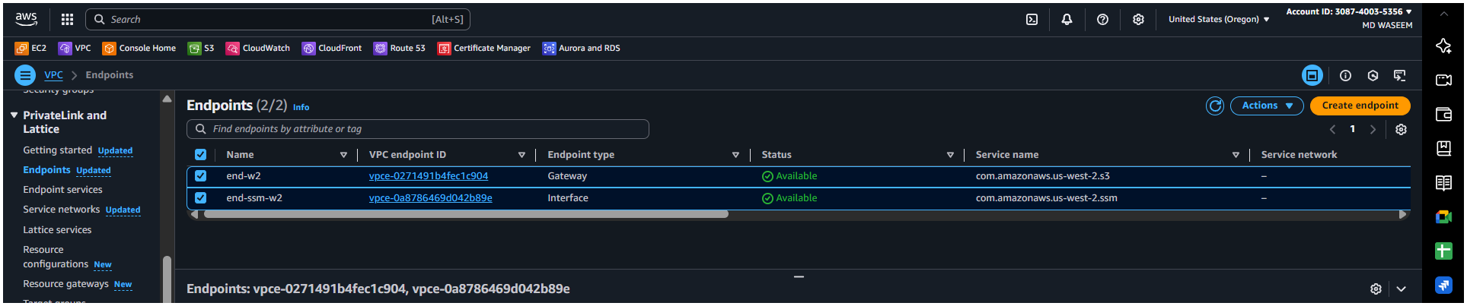

And also we need to created ec2 instances for all 4 region
In primary instances from region east 1 we have created to instances as we have public and private sub net in in public
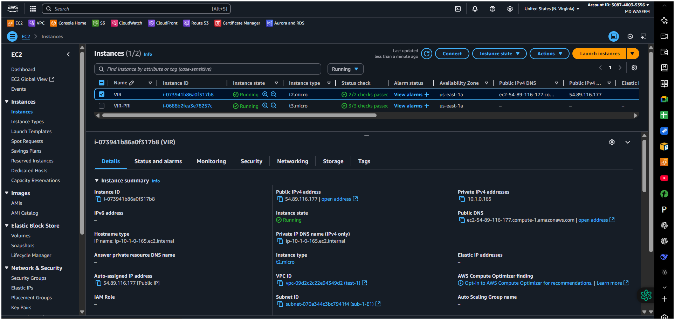

Here in pri instances we haven’t enable public ip
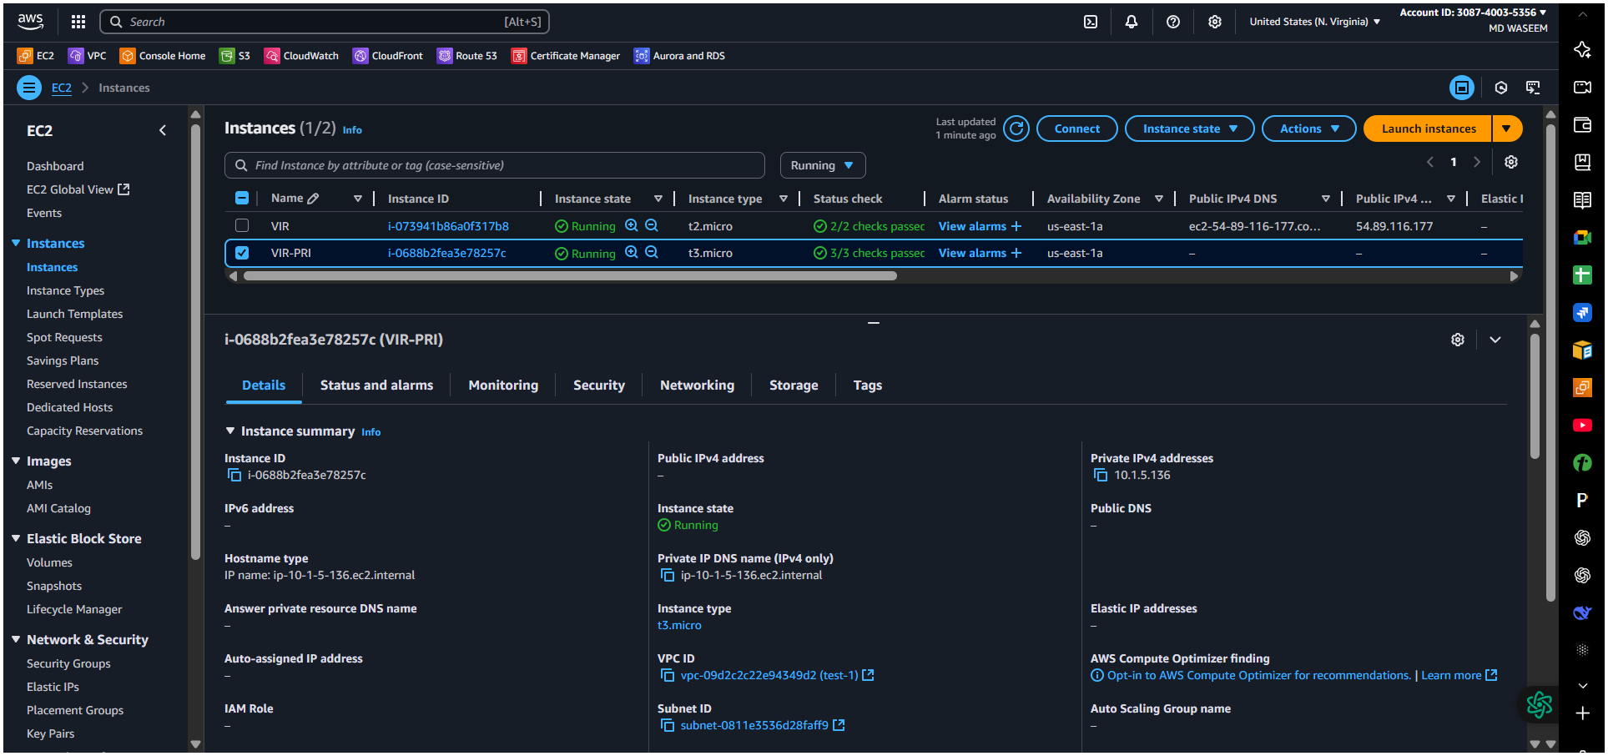
Instances from east 2
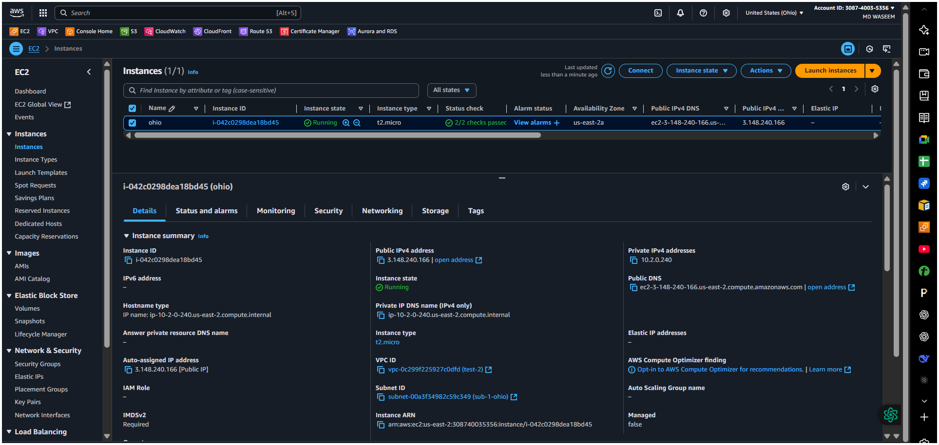

Instances from west 1
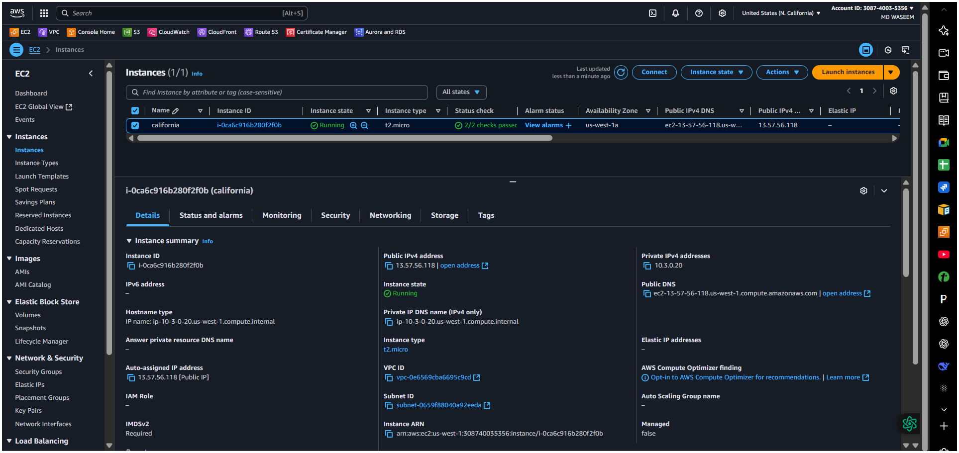
Instances from west 2
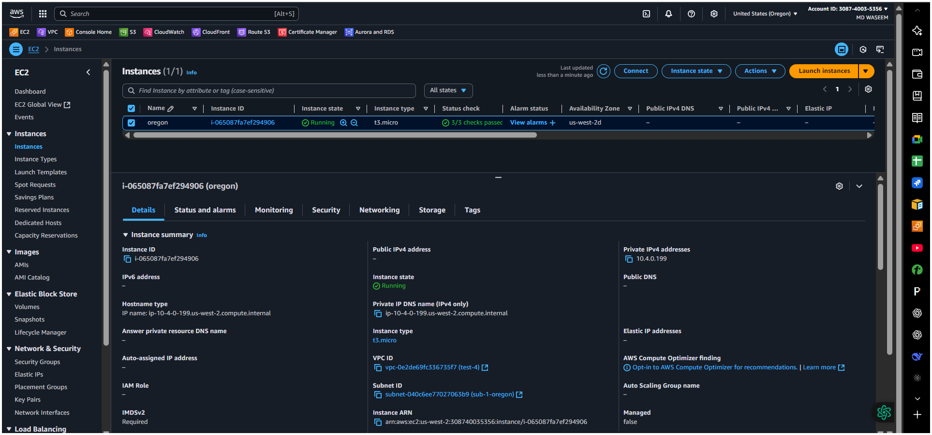

Trying to connect
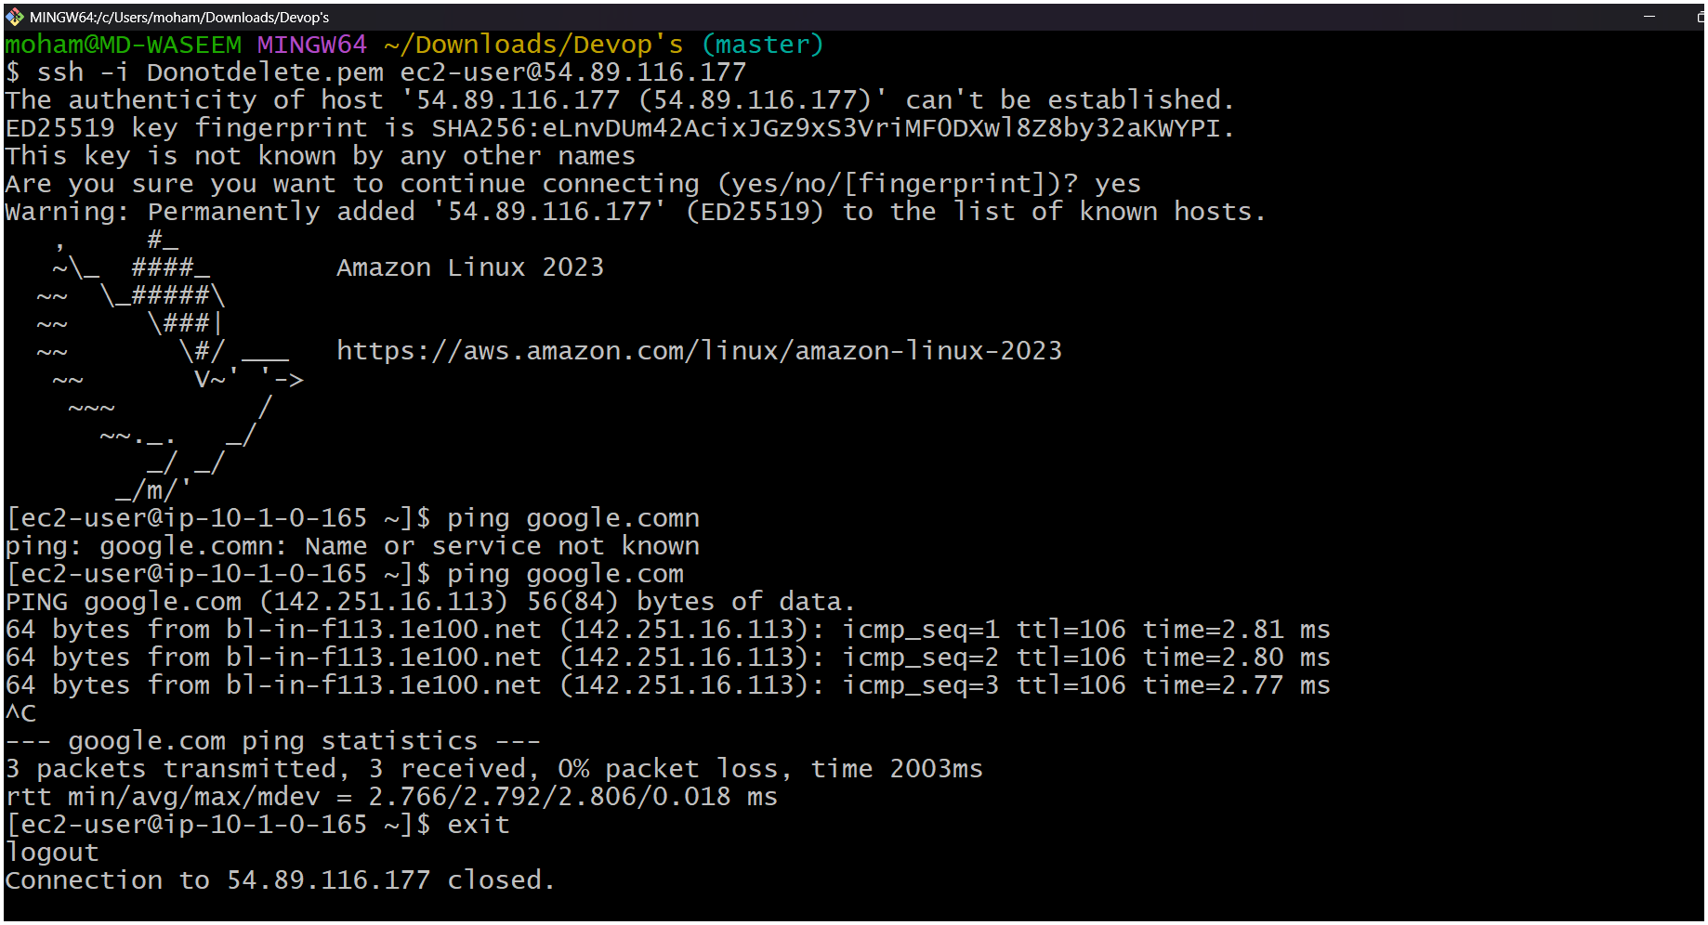

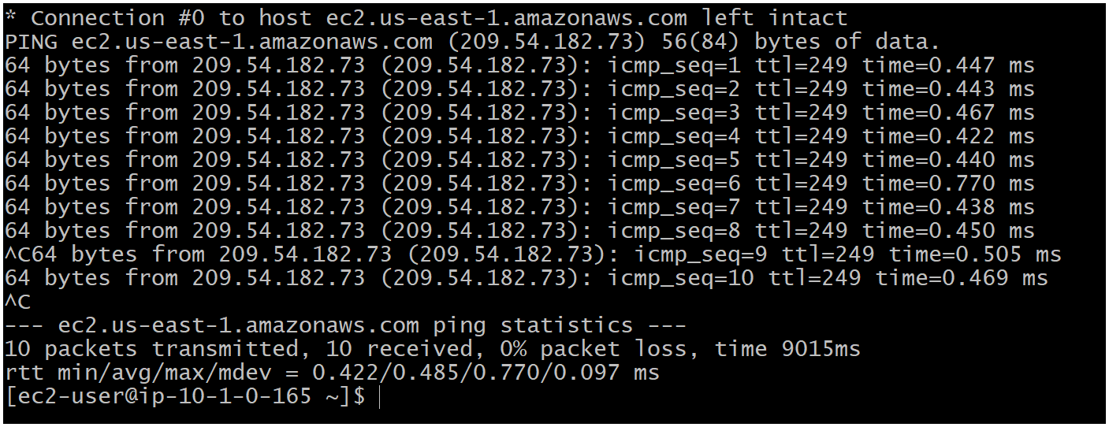
The task is incomplete not able to make connection with another region with ping

